**SAVEETHA INSTITUTE OF MEDICAL AND TECHNICAL SCIENCES**

**SIMATS Chennai, TamilNadu.**

Name:D.surya kiran

Reg.no: 192325057.

Course code:CSA0960

Couse Name: Programming in Java for Gaming Technologies.

1. Write a program to reverse a word using loop? (Not to use inbuilt functions)

Sample Input:

String: TEMPLE

Sample Output:

Reverse String: ELPMET

Program:

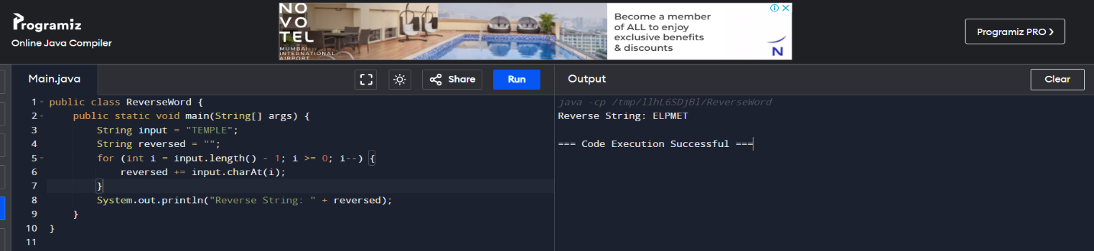

2. Write a program to convent the given string to integer?

Sample Input:

String: 1234

Sample Output:

Out put String: 1234.

Program:

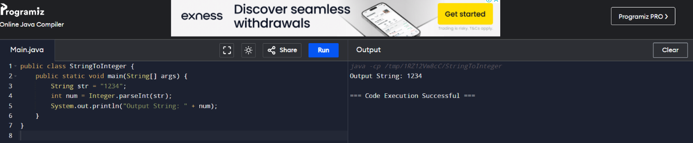

3. Write a program to check the entered user name is valid or not. Get both the inputs from the user.

Program:

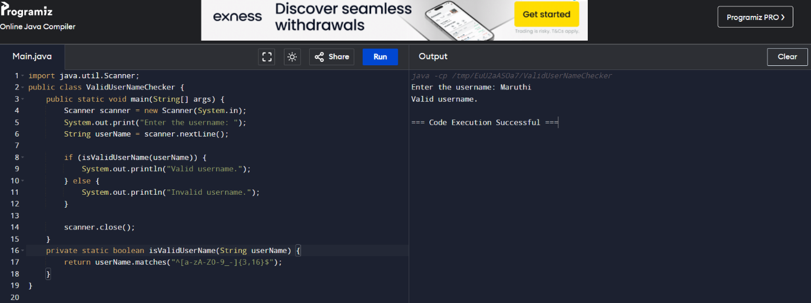

4. Write a program that would sort a list of names in alphabetical order Ascending or Descending, choice get from the user?

Sample Input:

Banana

Carrot

Radish

Apple

Jack

Order(A/D) : A

Sample Output:

Apple

Banana

Carrot

Jack

Radish

Program:

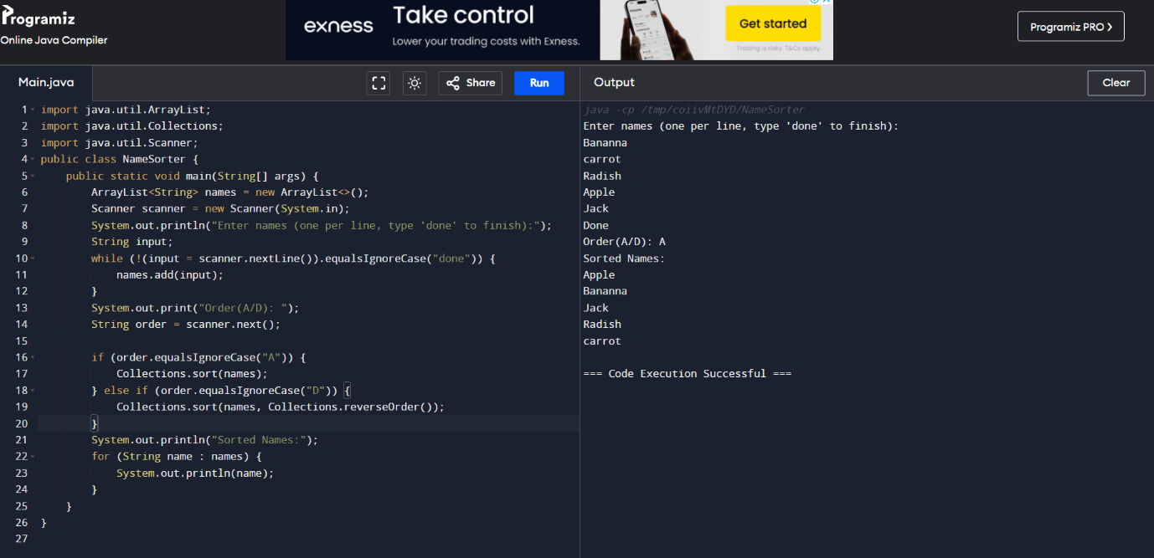

5.Write a program to print the special characters separately and print number of Special characters in the line?

Program:

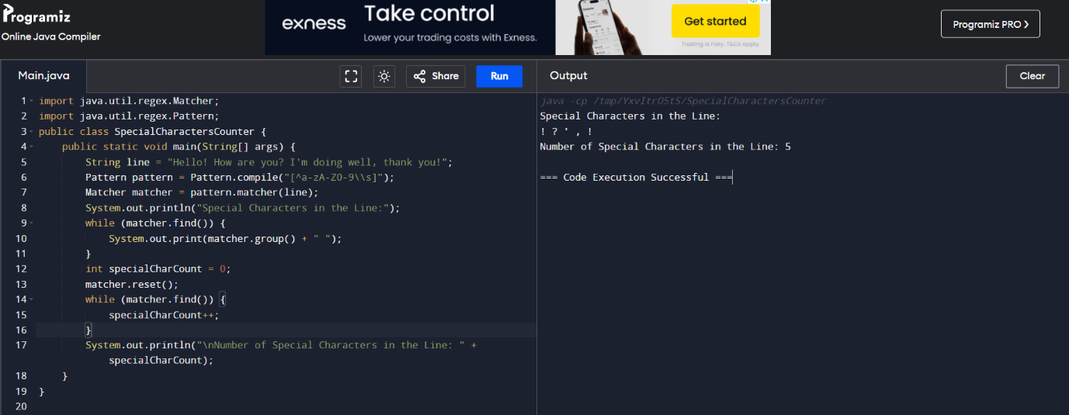

6. Write a program to print the number of vowels in the given statement?

Sample Input:

Saveetha School of Engineering

Sample Output:

Number o vowels = 12

Program:

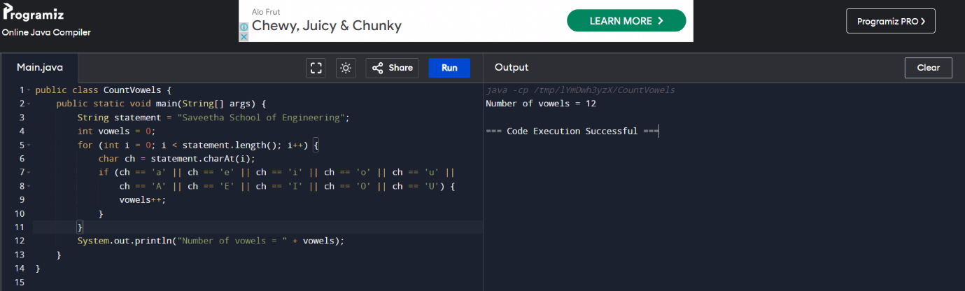

7. Write a program to print consonants and vowels separately in the given word

Sample Input:

Given Word: Engineering

Sample Output:

Consonants: n g n r n g

Vowels: e i e ei

Program:

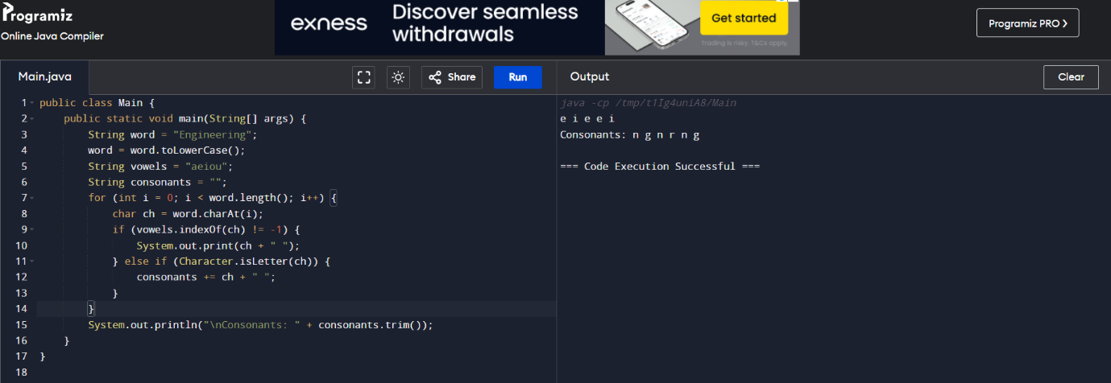

8. Write a program that finds whether a given character is present in a string or not. In case it is present it prints the index at which it is present. Do not use built-in find functions to search the character.

Sample Input:Enter the string: I am a programmer

Enter the character to be searched: p

Sample Output: P is found in string at index: 8.

Program:

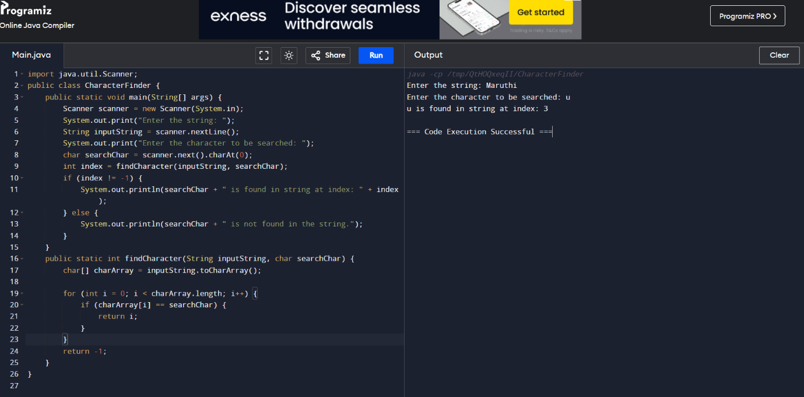

9. Write a program to arrange the letters of the word alphabetically in reverse order

Sample Input:

Enter the word: MOSQUE

Sample Output:

Alphabetical Order: U S Q O M E

Program:

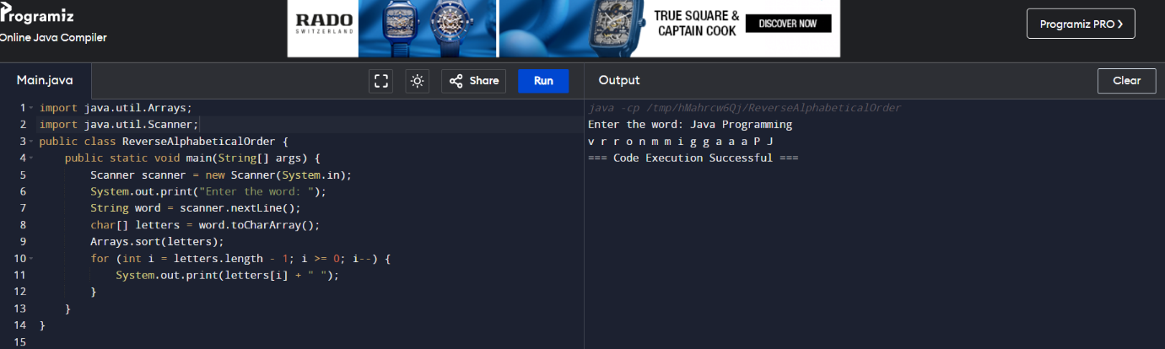

10. Write a program that accepts a string from user and displays the same string after removing vowels from it.

Sample Input & Output:

Enter a string: we can play the game

The string without vowels is: w cn ply thgm.

Program:

